# CS 255 System Design Document Template

## UML Diagrams

### UML Use Case Diagram

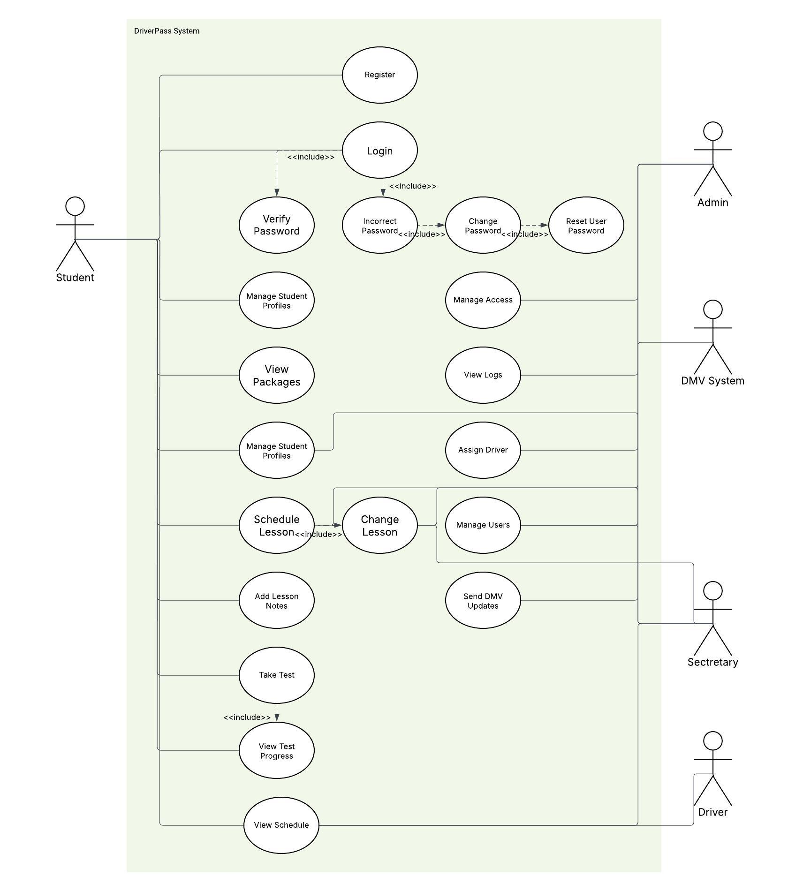

### UML Activity Diagrams

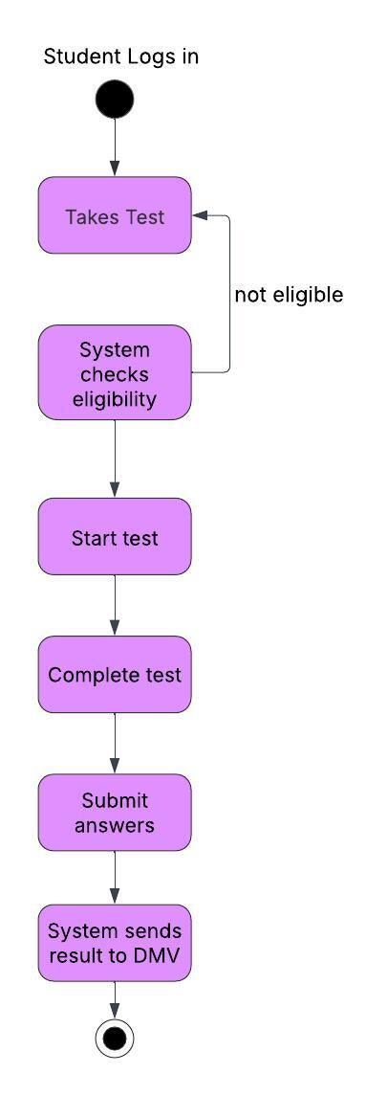

### UML Sequence Diagram

### 

### UML Class Diagram

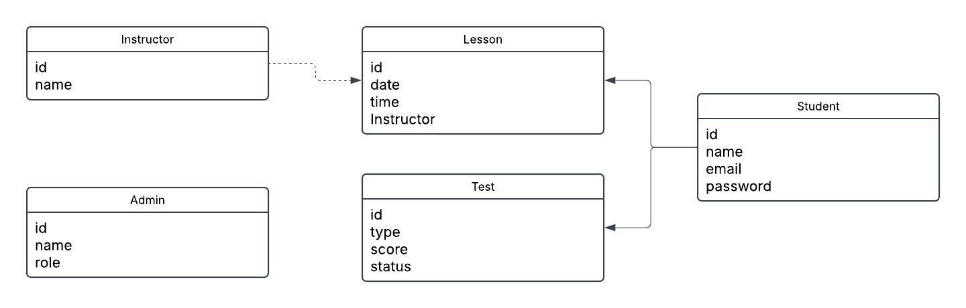

## Technical Requirements

*The DriverPass system needs a few basic things to work. Users will need a phone, tablet, or computer with internet access to use the system through a web browser like Chrome. The system itself will use a program to store information like user accounts, driving lessons, and test results. To build the system, developers will need tools like Lucidchart to make diagrams, GitHub to share and save the code, and a code editor like Visual Studio Code. The system will run on the internet using a hosting service, and it should be available all the time, work fast, and keep personal information safe.*